Test Results - MDD

Q1. AI Resume Screening Assistant (LangChain)

Objective
Build an AI-powered Resume Screening Assistant using LangChain and RAG (Retrieval-Augmented Generation).
The application should analyze uploaded resumes against a given Job Description (JD), retrieve relevant information from the resumes, and generate a candidate evaluation including a match score, strengths, weaknesses, missing skills, and hiring recommendation.

Project Description
Develop an AI assistant that allows recruiters to:
- Upload one or more resumes (PDF)
- Enter a Job Description
- Evaluate each resume against the JD
- Generate:
  - Match Score (0–100)
  - Matching & Missing Skills
  - Candidate Summary
  - Strengths & Weaknesses
  - Hiring Recommendation
The assistant should answer only from the uploaded resumes using RAG.

Technical Requirements
Your solution must include:
- LangChain
- LLM (OpenAI GPT-4o-mini or equivalent)
- PDF Document Loader
- Text Splitter
- Embedding Model
- Vector Database (FAISS/Chroma)
- Retriever
- Prompt Template
- Output Parser for structured responses
- Streamlit application

Example Test Cases
Demonstrate at least 3 evaluations and deploy using Streamlit.
Examples:
- Evaluate Resume A for a Data Scientist role.
- Compare Resume A and Resume B for the same JD.
- Identify missing skills in Resume C.
- Recommend the best candidate among multiple resumes.
- Generate a hiring recommendation with justification.

File Details:
File Name | Description
jd_app.py | Screen to upload Job Description
resume_app.py | Screen to Select available Job Description and Upload Resume
app_job_results.py | Screen to display the evaluation results by reading the result from a pickle file where the results are saved.
app_results.py | Screen to evaluate results and display on real time
llm.py | LLM is defined here
evaluation_prompt.py | Prompt to Evaluate Resume
requirements.txt | Library requirement file
evaluate_resume.py | File to evaluate each resume
evaluate_all_resume.py | File to evaluate all resumes
evaluate.ipynb | Python file to import libraries, load models, save job descriptions and resumes, perform chinking and embedding and then evaluate results and save everything in Pickle format.
job_desc.pkl | Saved job description meta data pickle file
jobs.faiss | Saved embedded job description.
job_result.pkl | Saved Job Evaluation result Pickle file.
resume_metadata.pkl | Save Resume metadata pickle file.
resume.faisee | Saved embedded resume.

Image 1: Job Description – Data Analyst is saved
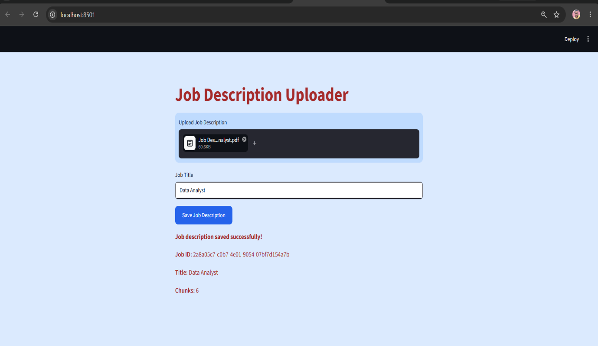

Image 2: Job Description – Data Scientist is Saved
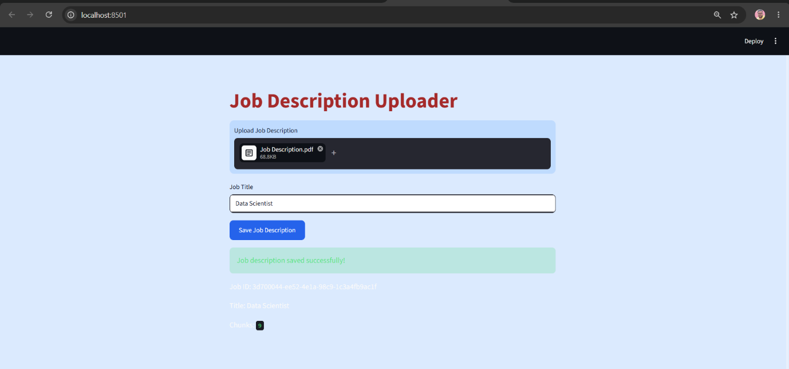

Image 3: Displaying available Job Description in Resume Pages

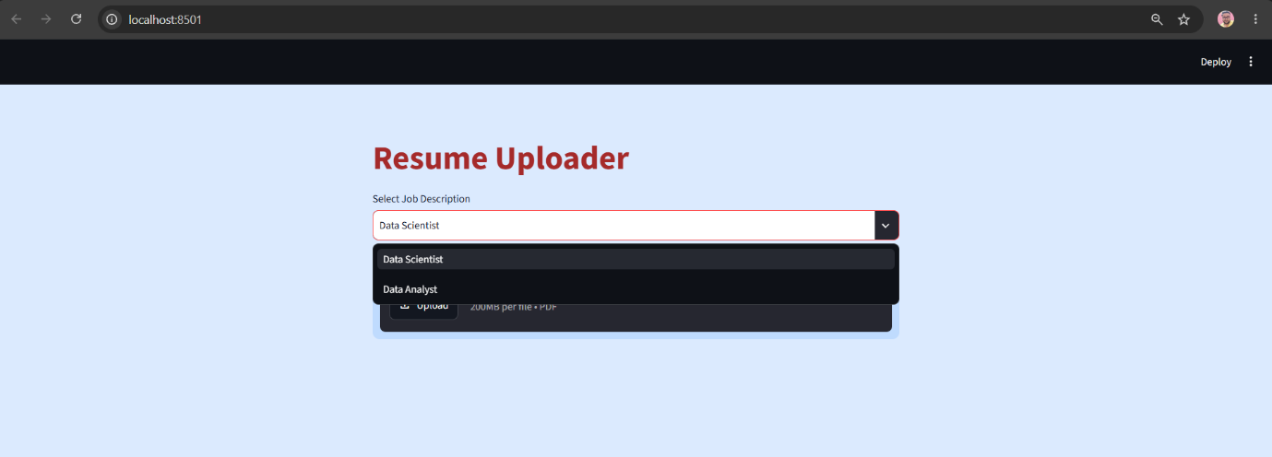

Image 4: Saved Resume A

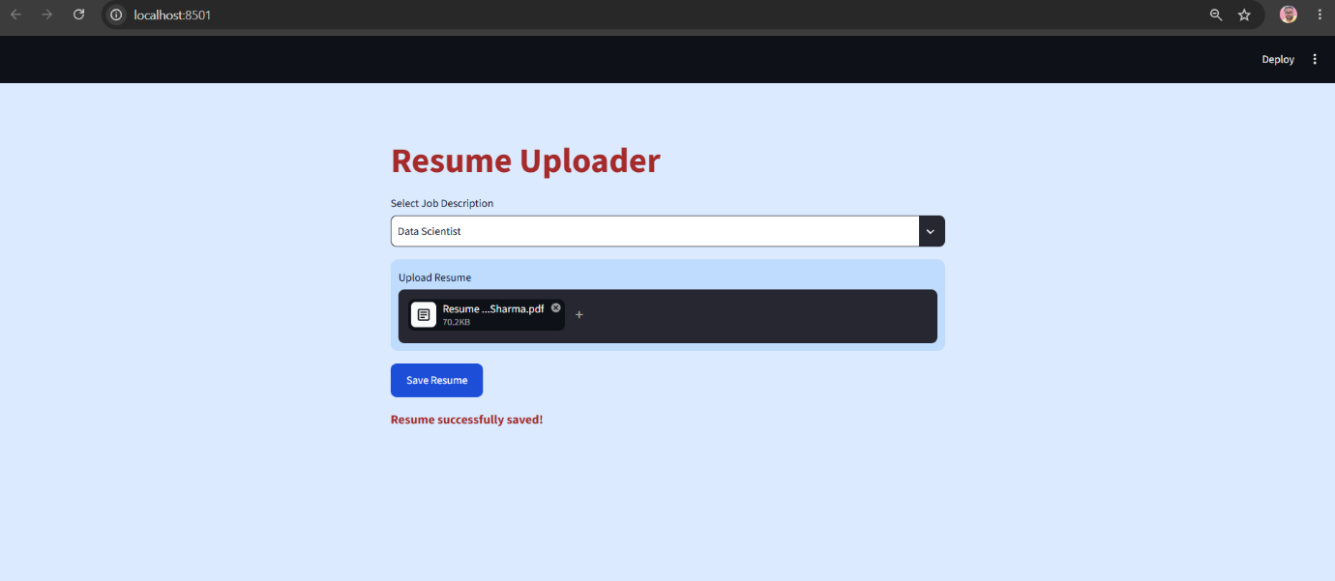

Image 5: Saved Resume B

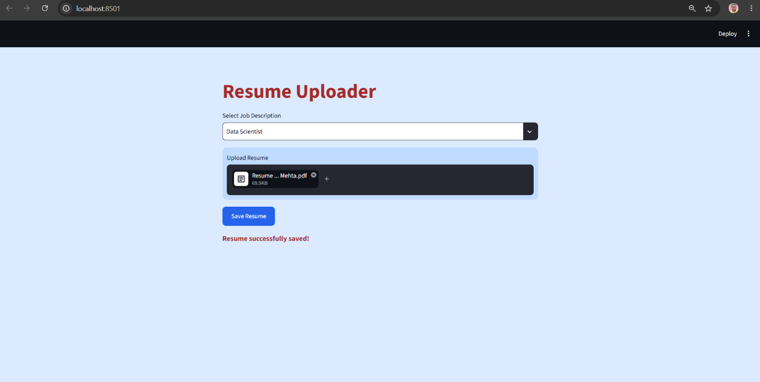

Image 6: Saved Resume C

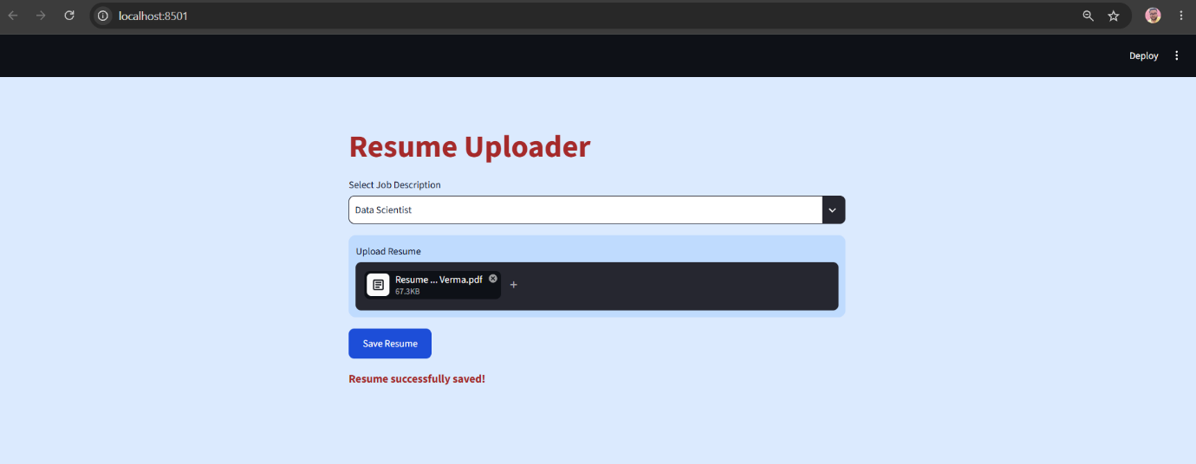

Image 7: Output – Data Analyst

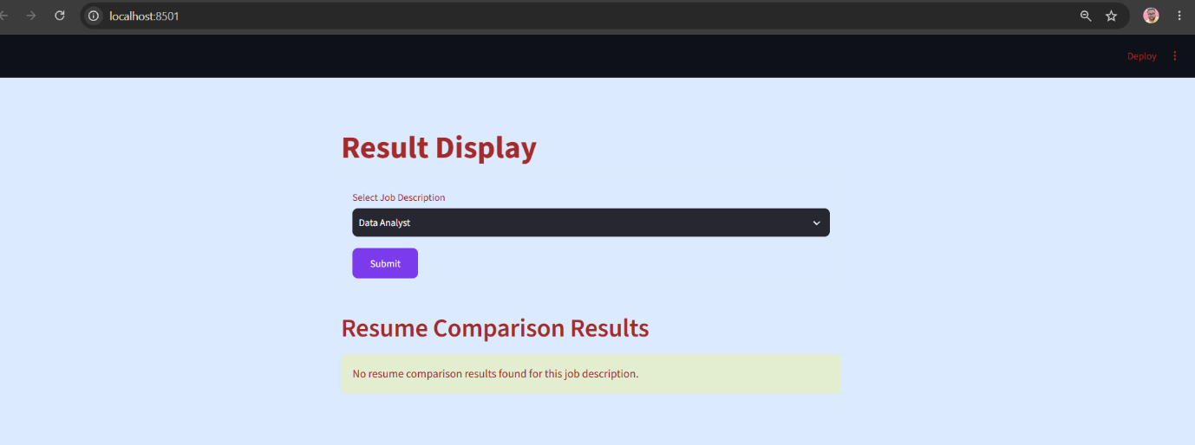

Image 8: Output Data Scientist

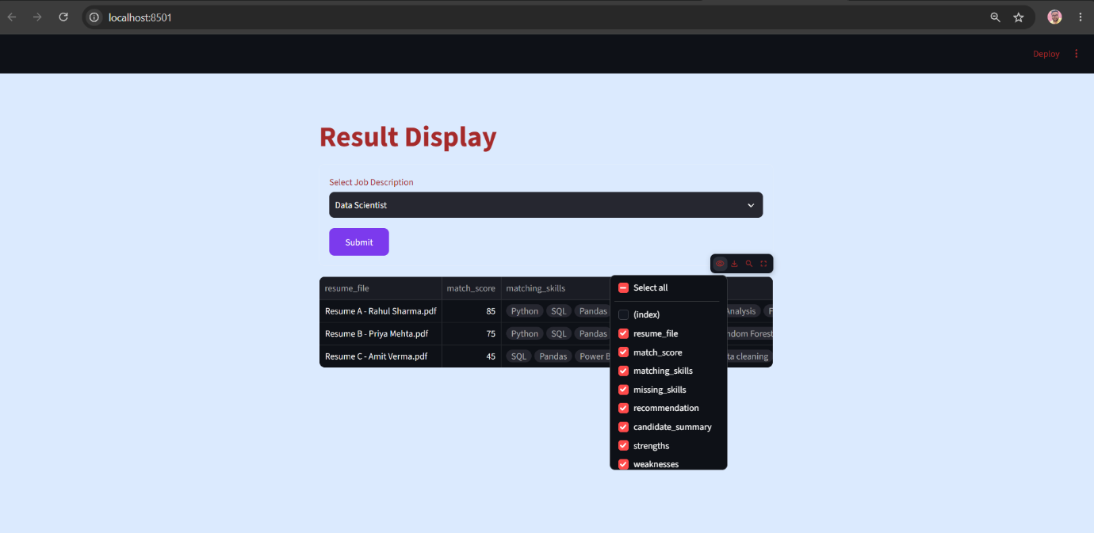

Image 9: Justification
